**Exp 6: Connecting Database with Firebase(Nosql)**

**Name : Keyur Patel**

**Roll No : 16010421073**

**Batch : A3**

**Exp no-6**

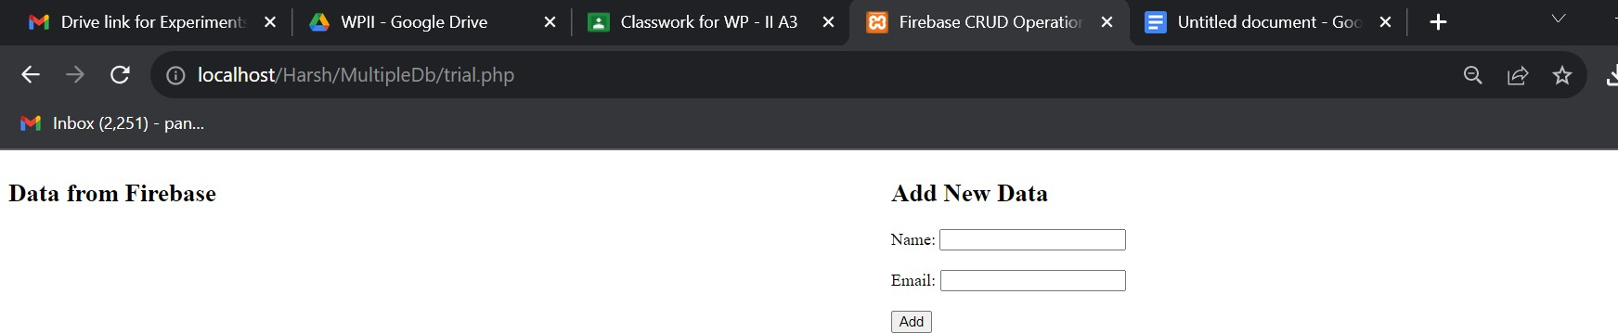SS:

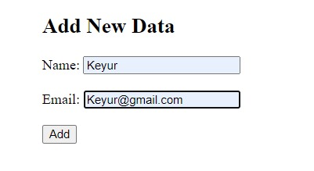

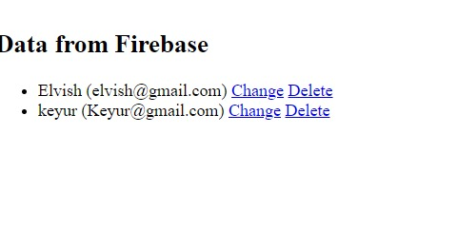

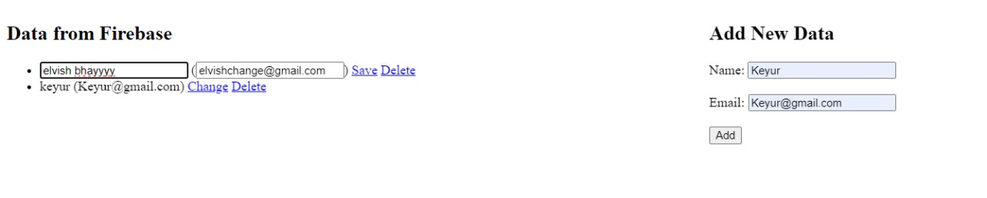

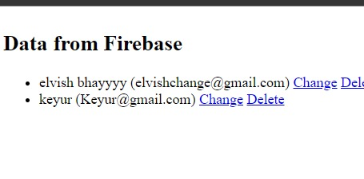

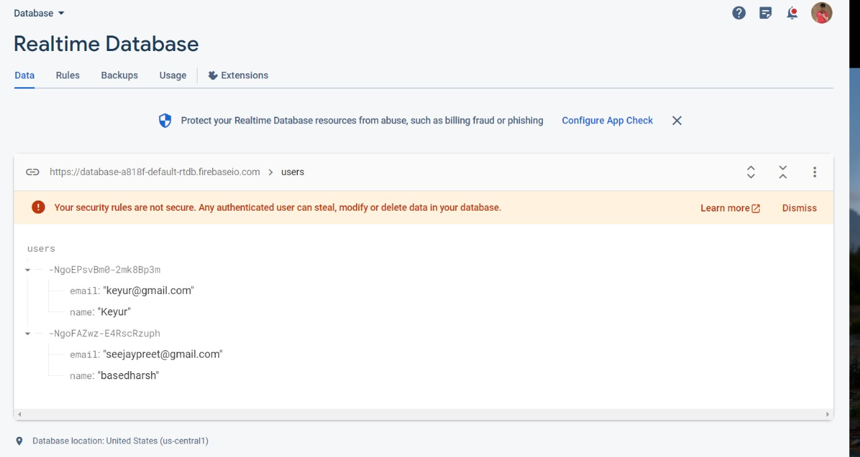

# **Code:**

<!DOCTYPE html>

<html>

<head>

<title>Firebase CRUD Operations</title>

<script src="https://code.jquery.com/jquery-3.6.0.min.js"></script>

<script>

$(document).ready(function() {

// Fetch data from fetch_data.php

$.ajax({

url: 'fetch_data.php', type: 'GET',

dataType: 'json', success: function(data) {

data.forEach(function(item) { var listItem = `<li><span

id='name_${item.key}'>${item.name}</span> (<span id='email_${item.key}'>${item.email}</span>) <span id='change_${item.key}'><a href='javascript:void(0);' onclick='editData("${item.key}")'>Change</a></span> <a href='delete.php?key=${item.key}'>Delete</a></li>`;

$('ul').append(listItem);

});

}

});

});

function editData(key) {

var name = document.getElementById("name_" + key).innerText; var email = document.getElementById("email_" + key).innerText;

document.getElementById("name_" + key).innerHTML = `<input type='text' id='new_name_${key}' value='${name}'>`;

document.getElementById("email_" + key).innerHTML = `<input type='text' id='new_email_${key}' value='${email}'>`;

document.getElementById("change_" + key).innerHTML = `<a href='javascript:void(0);' onclick='saveData("${key}")'>Save</a>`;

}

function saveData(key) {

var newName = document.getElementById("new_name_" +

key).value; key).value;

var newEmail = document.getElementById("new_email_" +

$.ajax({

url: 'save.php',

type: 'POST',

data: {key: key, name: newName, email: newEmail}, success: function(response) {

if(response === 'success') {

document.getElementById("name_" + key).innerText =

newName;

document.getElementById("email_" + key).innerText

= newEmail;

document.getElementById("change_" + key).innerHTML

= `<a href='javascript:void(0);' onclick='editData("${key}")'>Change</a>`;

} else {

alert('Failed to update data');

}

}

});

}

</script>

</head>

<body>

<div style="float: left; width: 50%;">

<h2>Data from Firebase</h2>

<ul>

<!-- Data will be appended here by jQuery -->

</ul>

</div>

<div style="float: right; width: 50%;">

<h2>Add New Data</h2>

<form action="update.php" method="post">

<label for="name">Name:</label>

<input type="text" id="name" name="name"><br><br>

<label for="email">Email:</label>

<input type="email" id="email" name="email"><br><br>

<input type="submit" value="Add">

</form>

</div>

</body>

</html>

**Save.php**

<?php include('dbcon.php');

if ($_SERVER['REQUEST_METHOD'] === 'POST') {

$key = $_POST['key'];

$name = $_POST['name'];

$email = $_POST['email'];

$updatedData = [ 'name' => $name, 'email' => $email

];

try {

$database->getReference('users/' . $key)->update($updatedData); echo 'success';

} catch (Exception $e) { echo 'failed';

}

}

?>

# **Update.php**

<?php error_reporting(E_ALL);

ini_set('display_errors', 1); echo "Inside update.php"; include('dbcon.php');

if ($_SERVER['REQUEST_METHOD'] == 'POST') {

echo "Inside POST";

$name = $_POST['name'];

$email = $_POST['email'];

$newData = [

'name' => $name, 'email' => $email

];

try {

$database->getReference('users')->push($newData); header('Location: ./trial.php');

} catch (Exception $e) {

echo 'Caught exception: ', $e->getMessage(), "\n";

}

} else {

echo "Not a POST request";

}

?>

# **Connect to firebase**

**Dbcon.php**

<?php

require DIR .'/vendor/autoload.php';

use Kreait\Firebase\Factory;

$factory = (new Factory())-> withProjectId('database-a818f')

->withServiceAccount('c:/xampp/htdocs/Harsh/MultipleDb/database-a818f-fire base-adminsdk-xjo10-8d9bf0776b.json')

->withDatabaseUri('https://database-a818f-default-rtdb.firebaseio.com/');

$database = $factory->createDatabase();

?>